PHYTHON OUTPUT

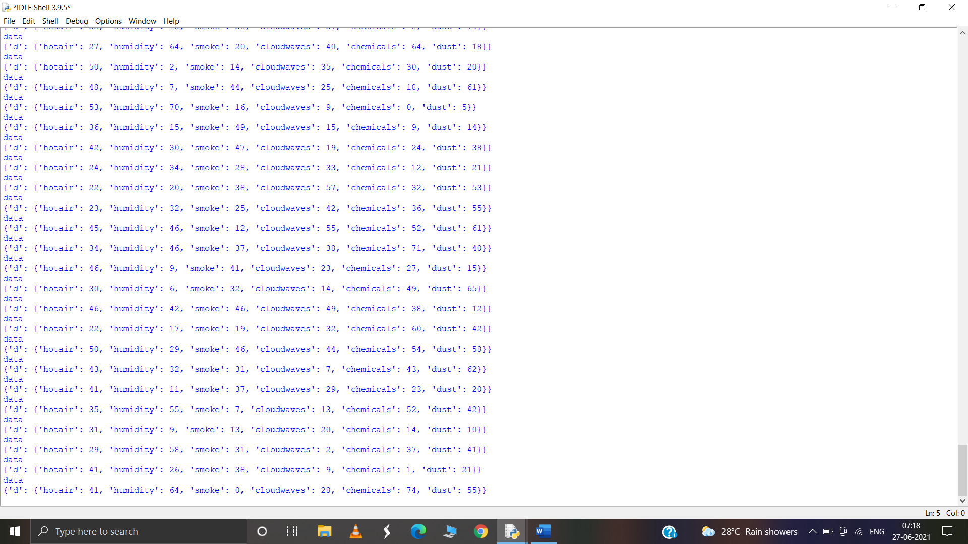

NODE RED CONNECTIONS

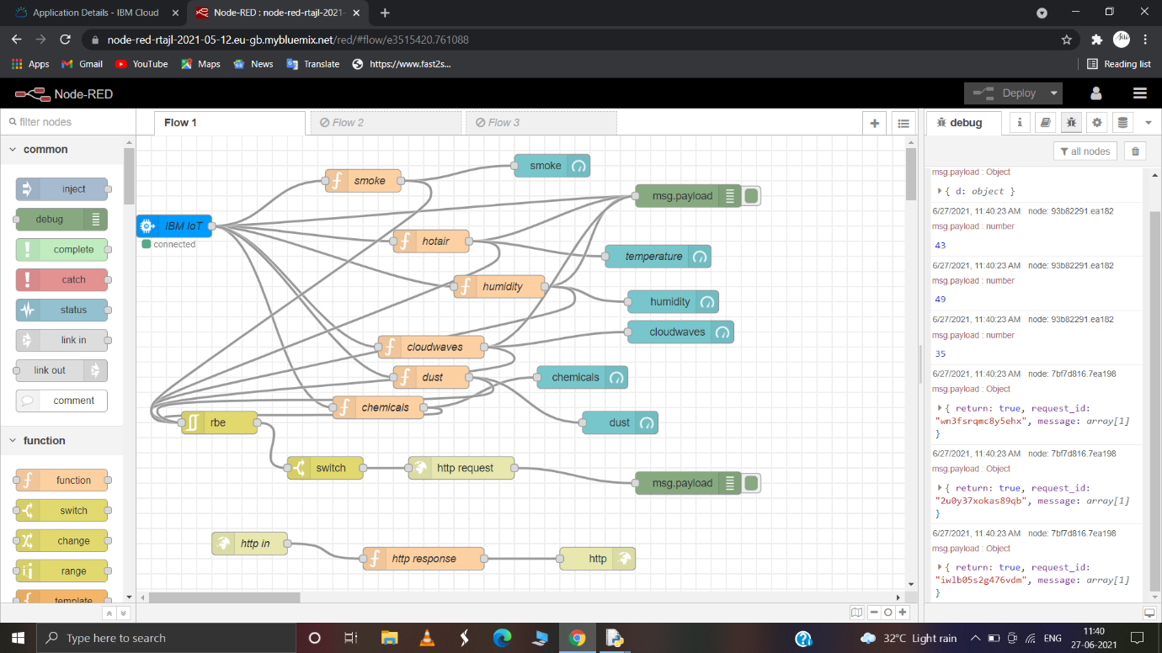

UI OUTPUT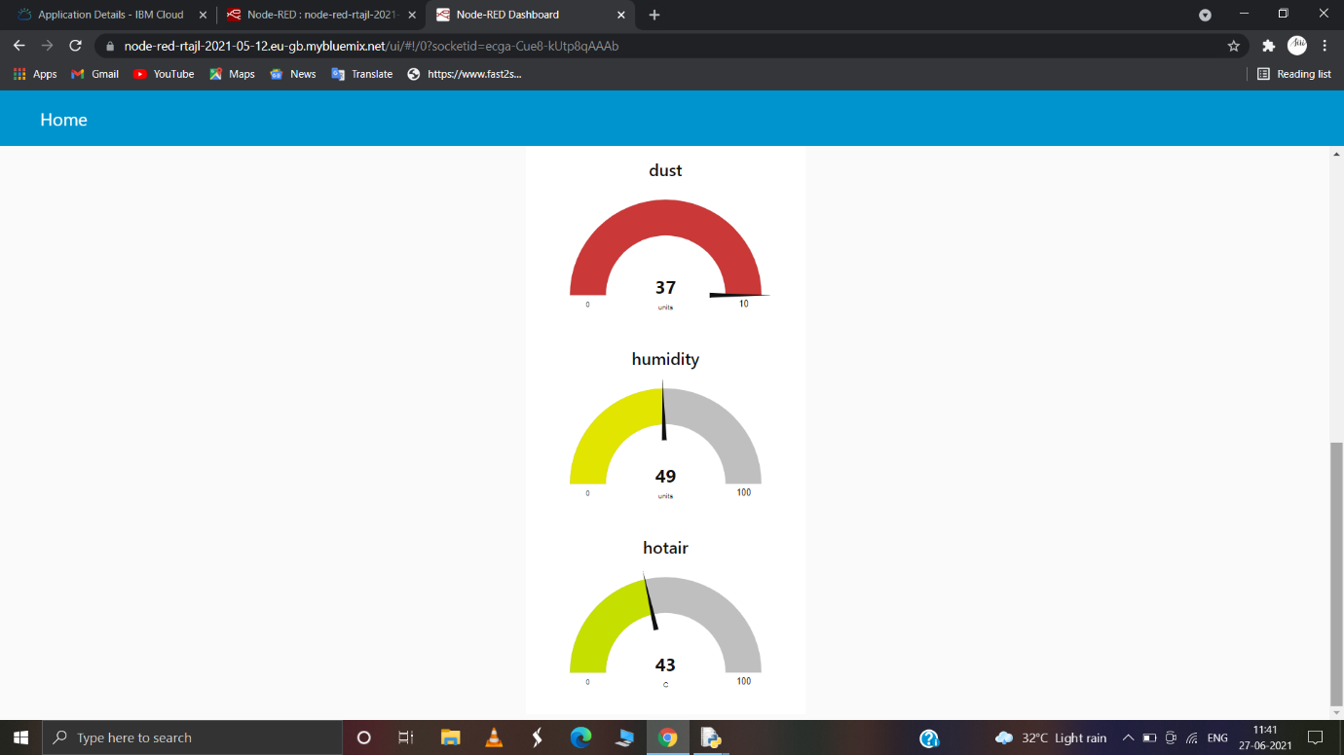

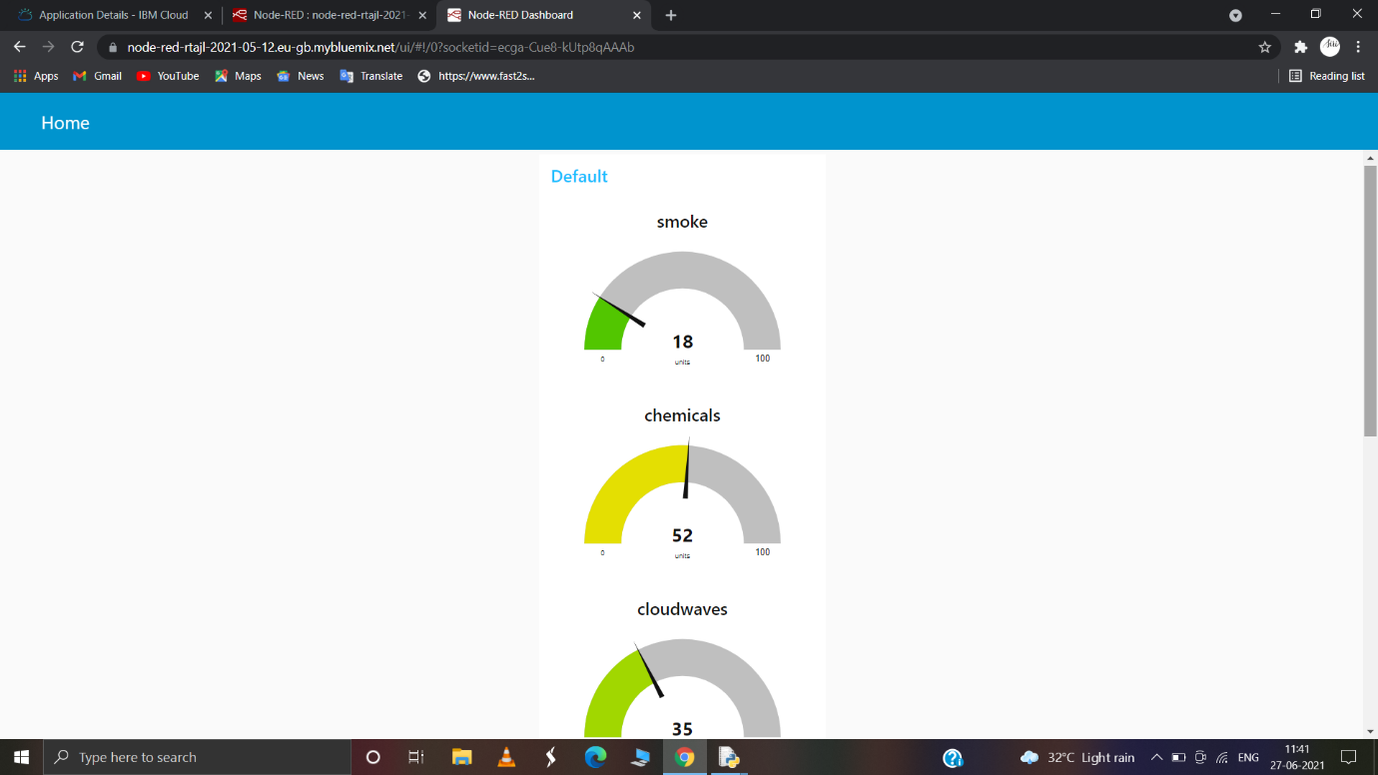

HTTP REQUEST OUTPUT

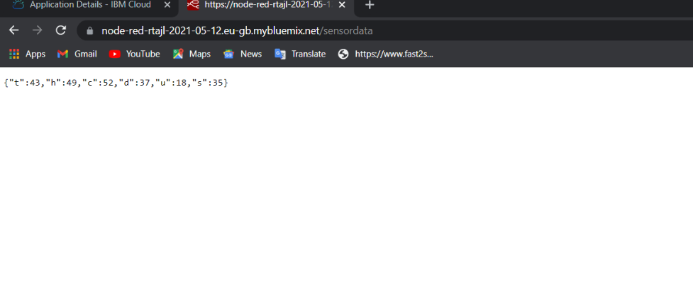

MIT DESIGN

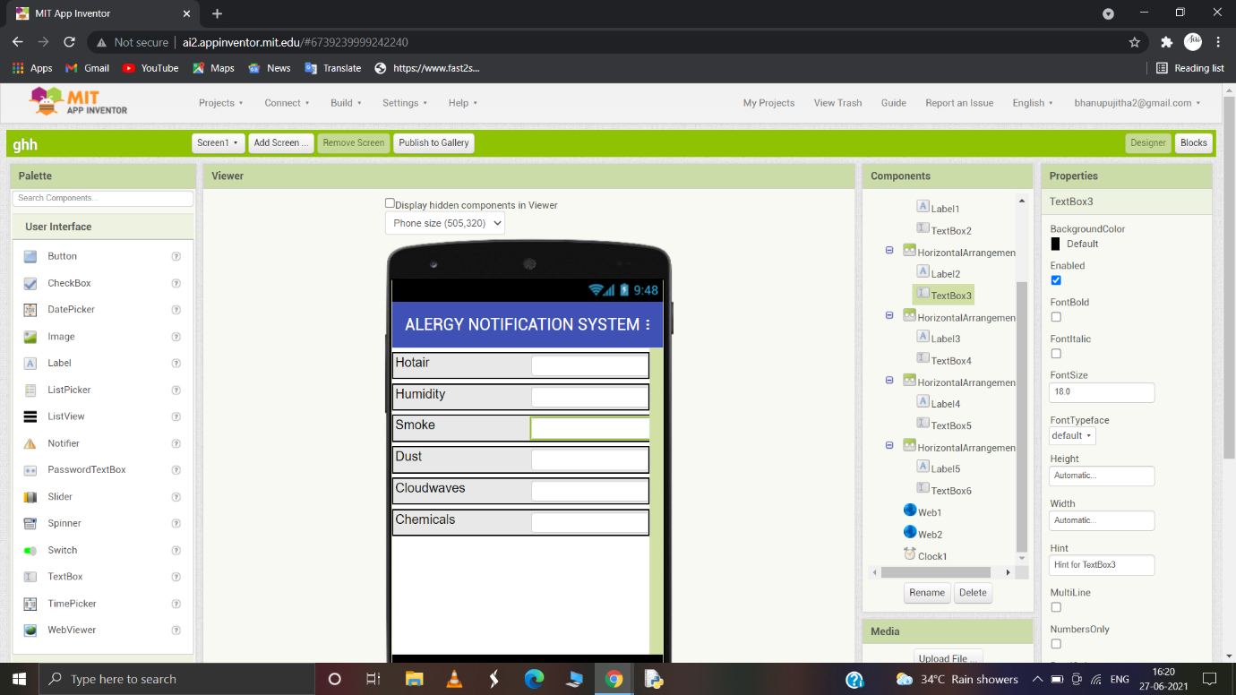

MIT BLOCK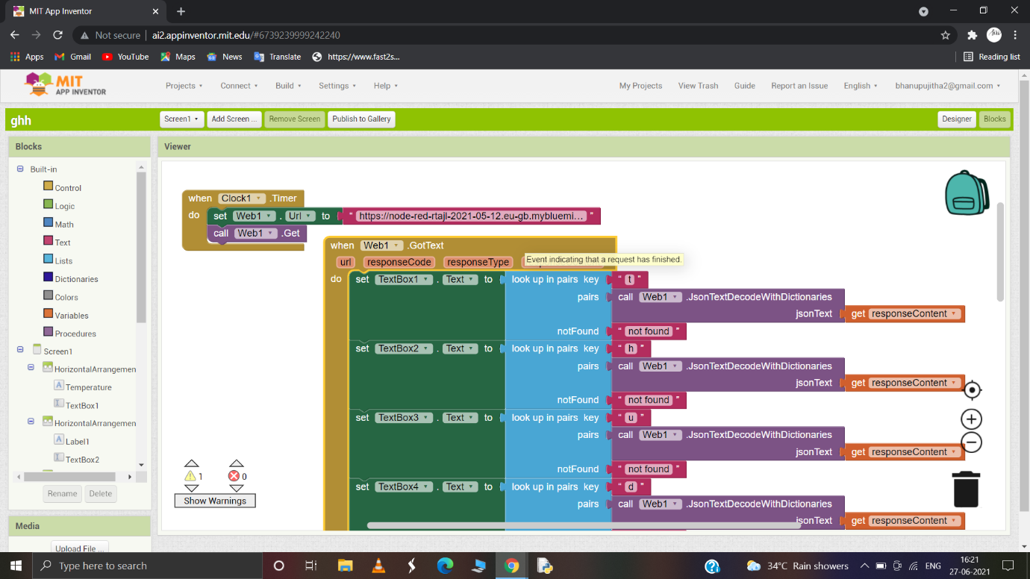

MIT APP DISPLAY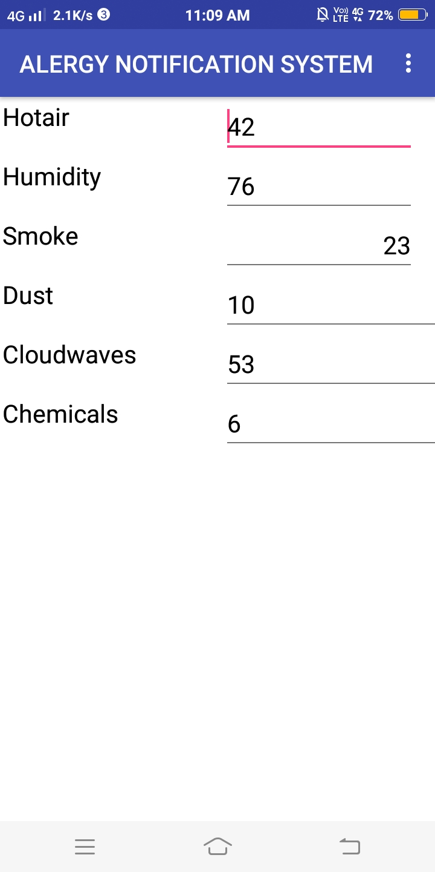

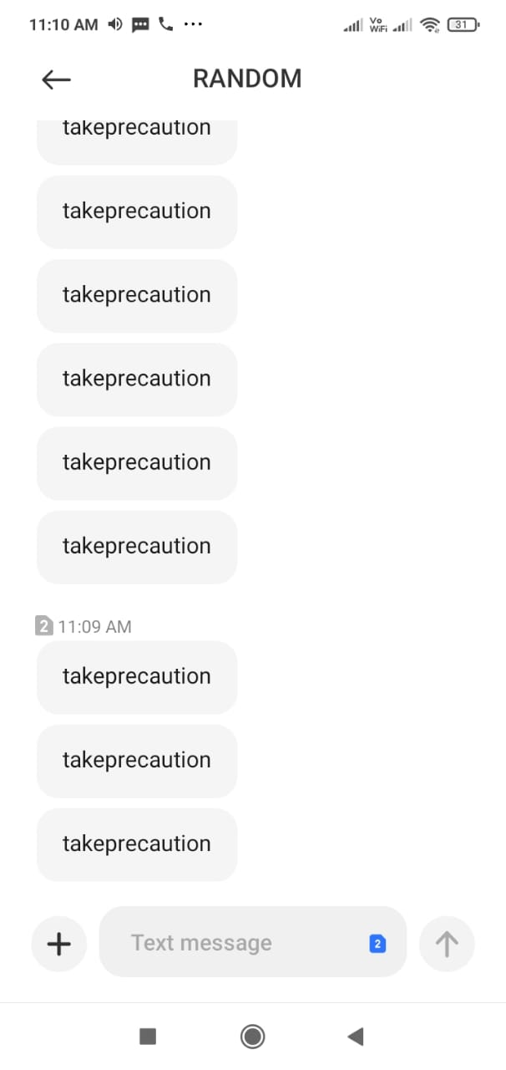NOTIFICATION PIC

Link for ui in nodered

petaruhttps://node-red-rtajl-2021-05-12.eu-gb.mybluemix.net/ui

Link for http request

https://node-red-rtajl-2021-05-12.eu-gb.mybluemix.net/sensordata